# **DBT JOBS - ERROR TRACKING**

Tracking DBT job errors through Snowsight dashboards allows you to identify and resolve issues in your data transformation workflows effectively. Snowsight provides real-time visibility into errors encountered during the execution of DBT jobs. You can monitor error rates, identify patterns, and track the types of errors occurring across different jobs or time periods. Snowsight's data visualization capabilities enable you to create custom metrics and visualizations specific to error tracking. This helps you quickly identify common error messages, their frequency, and their impact on job performance. Snowsight dashboards can be shared with relevant stakeholders, promoting collaboration and enabling teams to work together to address errors and improve the reliability of data transformation processes.

With below KPIs on Error Tracking of DBT jobs, you can proactively identify and address issues, ensuring the accuracy and quality of your data transformations.

## 

## **Error Run Rate in % :**

select (select count(*) from runs_list_atm where status='Error') as error_count,

(select count(*) from runs_list_atm) as total_count,

round((error_count/total_count)*100,2) as error_rate;



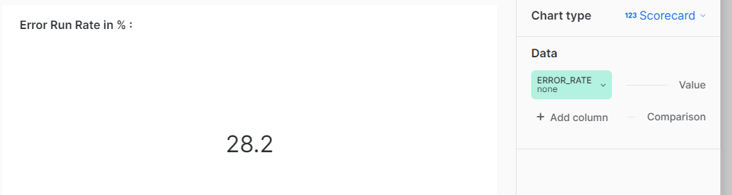

## 

## Canceled Run Rate in % :

select (select count(*) from runs_list_atm where status='Cancelled') as cancel_count,

(select count(*) from runs_list_atm) as total_count,

round((cancel_count/total_count)*100,2) as cancelled_rate;



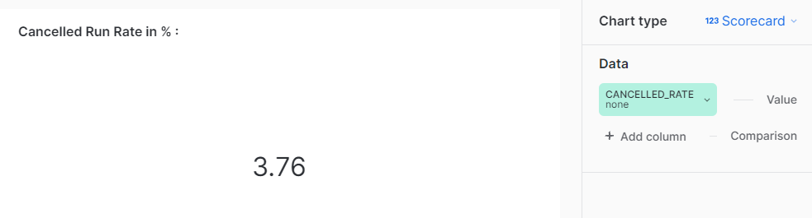

## 

## Job Run Execution Status :

select count(*), status from runs_list_atm group by status



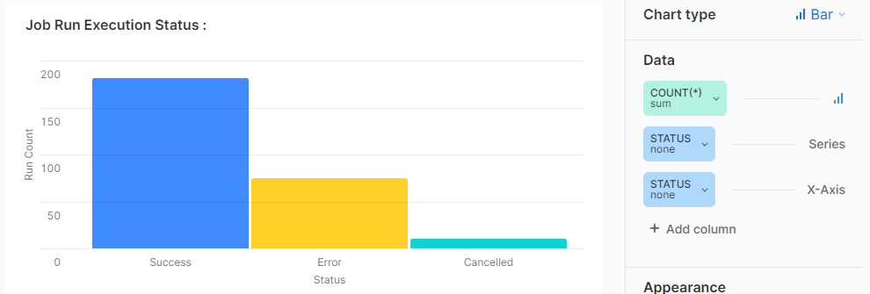

## 

## Error Rates on Each Job

SELECT

j.job_name,

COUNT(CASE WHEN status = 'Error' THEN 1 END) AS error_count,

COUNT(*) AS total_count,

ROUND((COUNT(CASE WHEN status = 'Error' THEN 1 END) / COUNT(*)) * 100, 2) AS error_rate

FROM runs_list_atm r

join

jobs_list_atm j on r.job_id=j.job_id

GROUP BY j.job_name



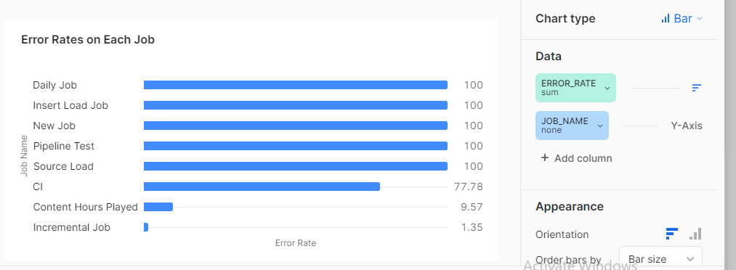

## 

## Canceled Jobs Rate :

SELECT

j.job_name,

COUNT(CASE WHEN status = 'Canceled' THEN 1 END) AS cancel_count,

COUNT(*) AS total_count,

ROUND((COUNT(CASE WHEN status = 'Canceled' THEN 1 END) / COUNT(*)) * 100, 2) AS cancel_rate

FROM runs_list_atm r

join

jobs_list_atm j on r.job_id=j.job_id

GROUP BY j.job_name



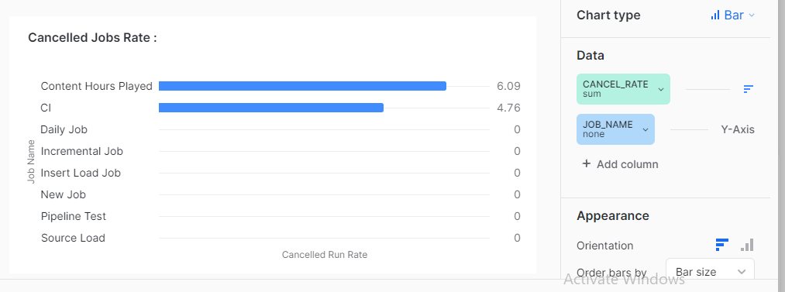

## 

## Unsuccessful Runs trend

SELECT

TRUNC(created_at, 'DAY') AS run_date,

status,

COUNT(*) AS run_count

FROM

runs_list_Atm

WHERE status in ('Error','Canceled')

GROUP BY

run_date,

status

ORDER BY

status desc;



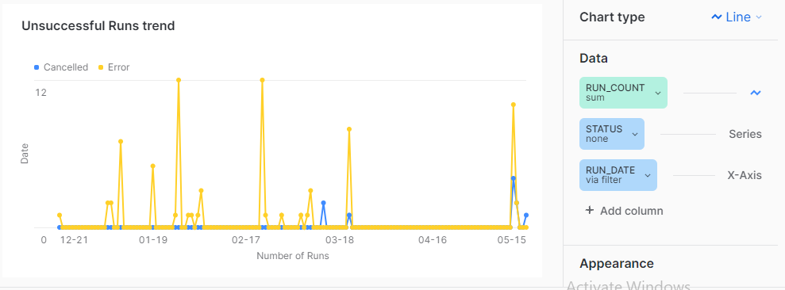

## 

## Jobs terminated due to Snowflake errors :

SELECT ERROR_MESSAGE , count(*) ,

CASE

WHEN ERROR_CODE =002003 THEN 'Compilation Error'

WHEN ERROR_CODE =000630 THEN 'Statement or Warehouse Timeout'

WHEN ERROR_CODE =000604 THEN 'Object does not exist'

ELSE 'Others'

END AS category

FROM DBT_DASHBOARD_DB.ACCOUNT_USAGE.QUERY_HISTORY

WHERE ERROR_CODE IS NOT NULL

group by category,error_message;



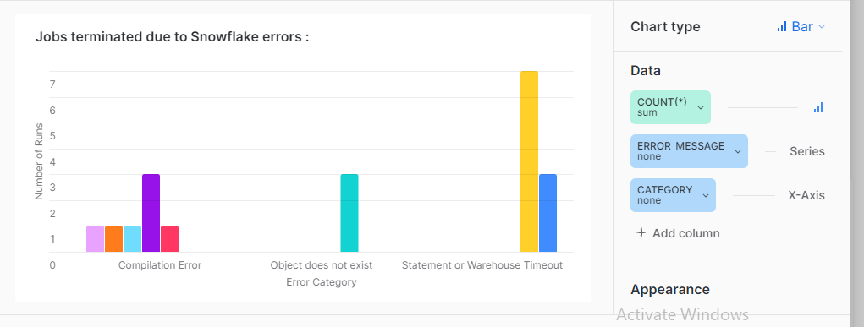

## 

## Job runs canceled by DBT :

(select (split(status_message,'.')[0]) as run_terminated, status,count(*), job_name from dbt_dashboard_db.dbt_coe.runs_list_atm

join dbt_dashboard_db.dbt_coe.jobs_list_atm using (job_id)

where (status_message ILIKE '%canceled%' ) and (status_message NOT ILIKE '%User%') and (status_message NOT LIKE '%user%')

group by status, status_message, job_name)

union all

(select (split(status_message,',')[0]) as message, status,count(*),job_name from dbt_dashboard_db.dbt_coe.runs_list_atm

join dbt_dashboard_db.dbt_coe.jobs_list_atm using (job_id)

where status_message NOT ILIKE '%canceled%'

group by message, status, job_name)



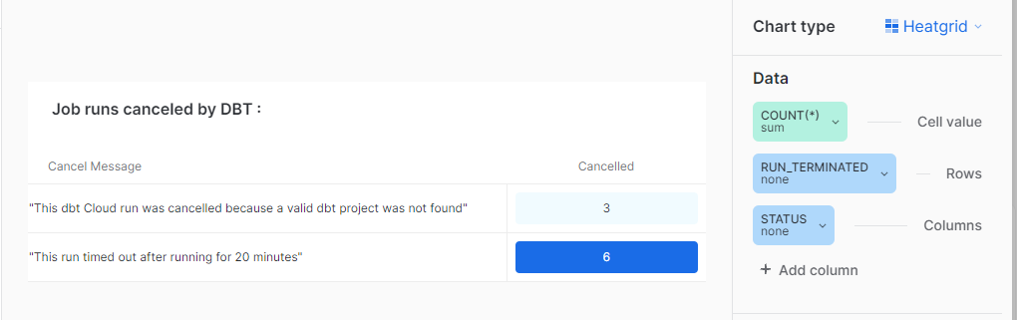

## Job runs canceled by User :

(select (split(status_message,'.')[0]) as user_terminated, status,count(*), job_name from runs_list_atm

join jobs_list_atm using (job_id)

where lower(status_message) LIKE '%user%'

group by status, status_message, job_name)



